The Transformer Network and Its Applications in Cybersecurity

Introduction
The Transformer network, introduced in the seminal paper "Attention is All You Need" by Vaswani et al. in 2017, represents a paradigm shift in deep learning architectures, particularly for sequence processing tasks. Unlike traditional recurrent neural networks (RNNs) such as LSTMs, which process data sequentially and suffer from issues like vanishing gradients and limited parallelization, Transformers rely entirely on attention mechanisms to capture dependencies between input elements regardless of their distance in the sequence. This enables efficient handling of long-range dependencies and parallel computation, making Transformers highly scalable and effective for large datasets.
The core architecture consists of an encoder and a decoder stack, each comprising multiple identical layers. The encoder processes the input sequence to generate a continuous representation, while the decoder generates the output sequence autoregressively. Key innovations include multi-head self-attention, positional encodings, and point-wise feed-forward networks, all interspersed with residual connections and layer normalization for stable training. Transformers have revolutionized fields like natural language processing (NLP), computer vision, and beyond, powering models like BERT, GPT, and Vision Transformers (ViT).

Key Components

Multi-Head Self-Attention Mechanism
The attention mechanism is the heart of the Transformer, allowing the model to weigh the importance of different parts of the input when processing each element. Specifically, it uses scaled dot-product attention, where for a sequence of inputs, we compute Queries (Q), Keys (K), and Values (V) through linear projections. The attention scores are calculated as the softmax of (Q · K^T) / sqrt(d_k), where d_k is the dimension of the keys, scaled to prevent vanishing gradients. These scores are then used to weight the Values, producing a context-aware representation.
Multi-head attention extends this by performing attention in parallel across multiple "heads," each learning different aspects of relationships, and concatenating the results. This enables the model to jointly attend to information from different representation subspaces.
Visualization of the attention layer mechanism:
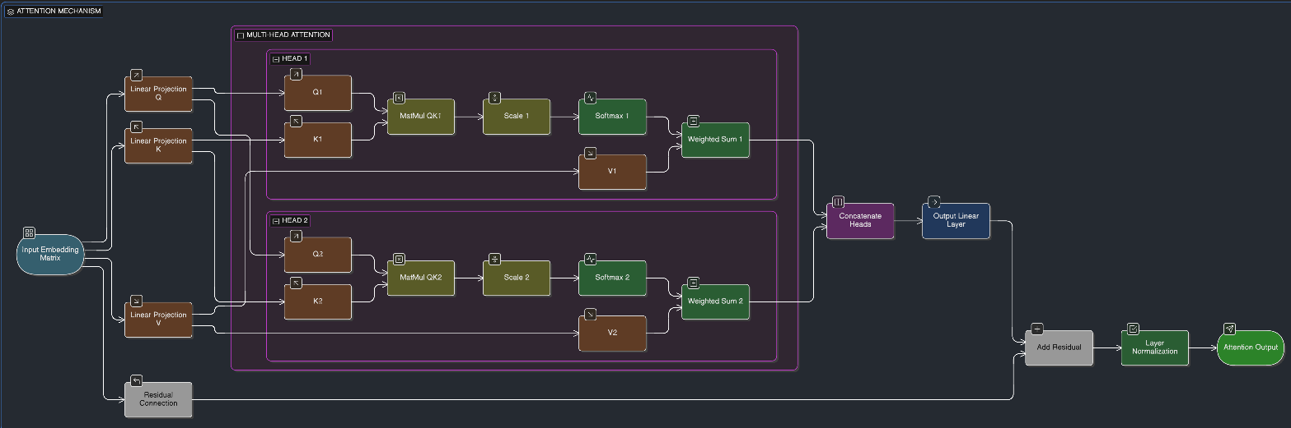

Positional Encoding
Since Transformers lack inherent sequential order (unlike RNNs), positional encodings are added to the input embeddings to inject information about the relative or absolute positions of tokens. These are typically generated using sine and cosine functions of different frequencies: PE(pos, 2i) = sin(pos / 10000^{2i/d_model}) and PE(pos, 2i+1) = cos(pos / 10000^{2i/d_model}), where pos is the position and i is the dimension. This creates unique, fixed encodings that allow the model to discern order and distances.
This mechanism ensures that the model can handle variable-length sequences and maintain permutation invariance without positional data.
Visualization of positional encoding:
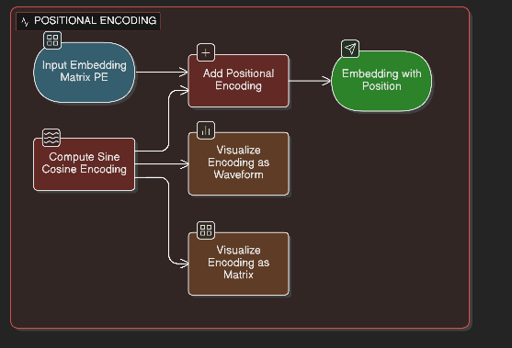

Applications in Cybersecurity
Transformers have found extensive applications in cybersecurity due to their ability to process sequential data like network traffic, logs, and text-based threat intelligence with high accuracy and efficiency.
- Malware Detection: Transformers, such as BERT and Vision Transformers (ViT), excel at identifying malicious software like ransomware, spyware, and trojans by analyzing code patterns, API calls, or binary sequences. They capture contextual dependencies that traditional methods miss, achieving high precision in classifying subtle indicators of compromise. Graph Transformers are particularly useful for graph-structured data, modeling interconnections in system behaviors.
- Anomaly and Intrusion Detection: In IoT environments, Large Transformer Models (LTMs) enable real-time anomaly detection for intrusion detection systems (IDS), automating threat analysis on resource-constrained devices. For network systems, AI-driven Transformer frameworks with BERT and Zero-Shot Learning detect known and unknown threats with minimal human input, outperforming conventional methods.
- DDoS Attack Detection: Transformers analyze network traffic for malicious patterns using self-attention to handle long sequences and parallelism for real-time detection. Surveys show F1-scores ranging from 47.40% to 100%, with integration of other AI techniques enhancing generalization to new attacks.
- Malicious URL Prediction: Transformer models are trained to detect phishing or malicious URLs by processing textual and structural features, performing on par with other deep learning methods like CNNs and LSTMs.
- Predicting Cyber Attack Consequences: BERT combined with Hierarchical Attention Networks (HAN) predicts multi-label impacts (e.g., availability, access control) from textual descriptions, achieving accuracies up to 97.2%, surpassing traditional CNN and LSTM models.
- Threat Detection and Response: Overall, Transformers enhance cybersecurity by processing vast data volumes for proactive defenses, with tailored architectures addressing specific challenges like zero-day attacks.
These applications leverage Transformers' strengths in NLP for threat intelligence parsing and sequential data for behavioral analysis, making them indispensable in modern cybersecurity frameworks.
Practical Example (Python)
from transformers import AutoModelForSequenceClassification, AutoTokenizer
import torch

# Load pre-trained BERT
model_name = "bert-base-uncased"
tokenizer = AutoTokenizer.from_pretrained(model_name)
model = AutoModelForSequenceClassification.from_pretrained(model_name, num_labels=2)

# Sample network traffic
samples = ["Suspicious TCP connection", "Normal HTTP request"]
inputs = tokenizer(samples, padding=True, truncation=True, return_tensors="pt")

# Predictions
outputs = model(**inputs)
predictions = torch.argmax(outputs.logits, dim=-1)
print(predictions) # 0 = normal, 1 = suspicious

Conclusion
Transformers provide efficient sequence modeling through self-attention and positional encoding. In cybersecurity, they are applied in malware detection, intrusion detection, phishing detection, and threat intelligence, enabling proactive and accurate defense mechanisms.

